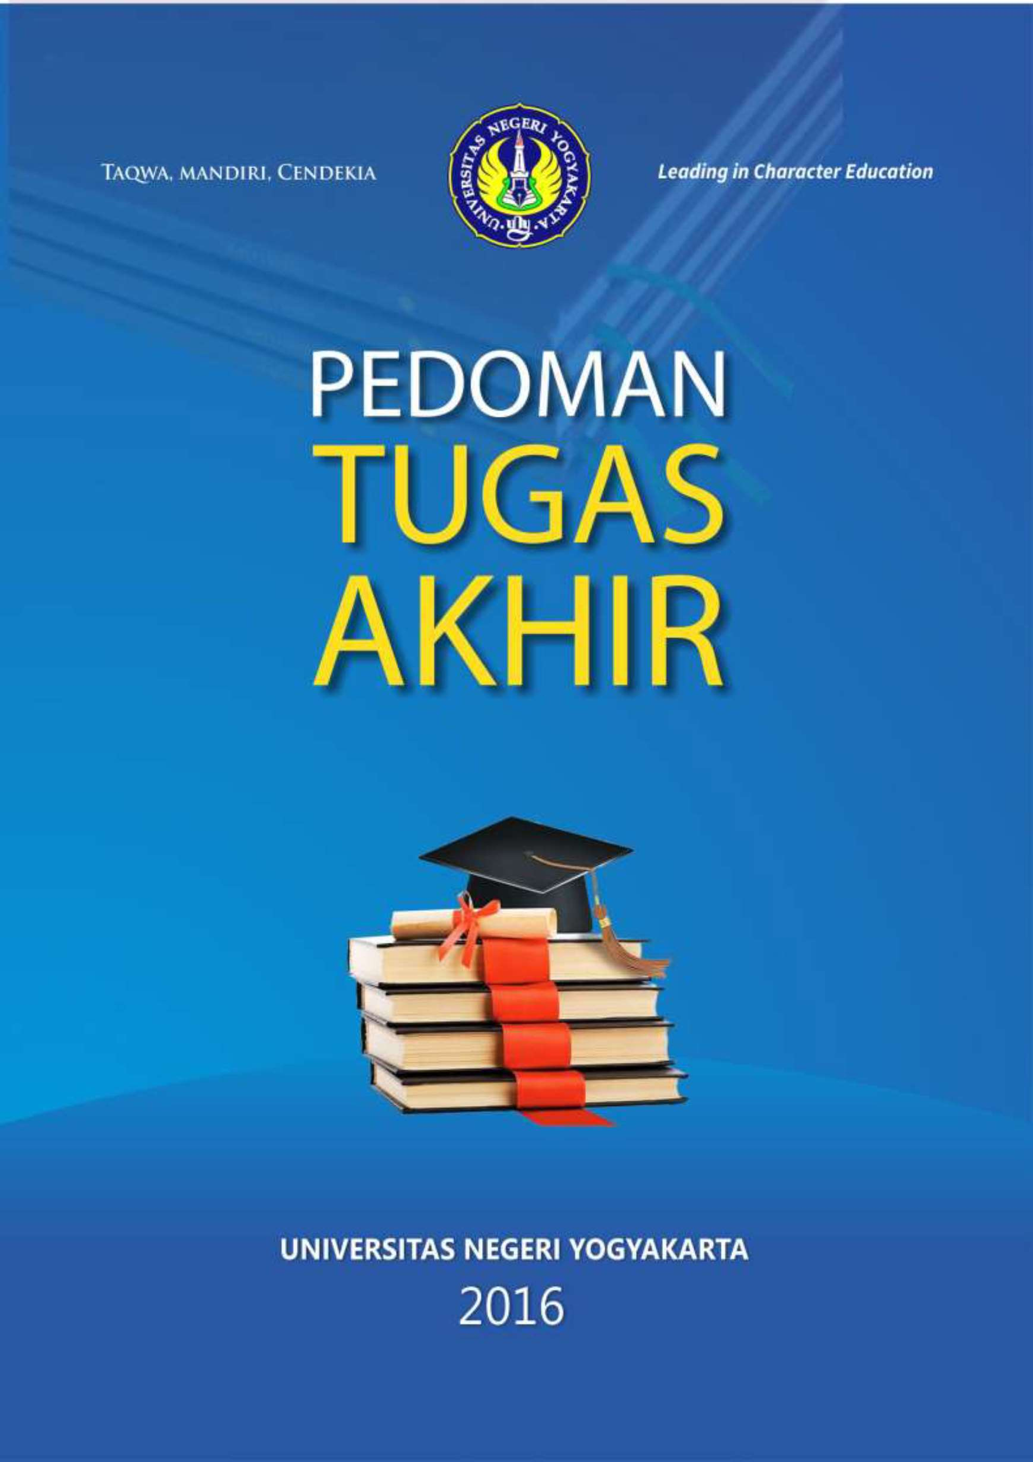
i

FINAL ASSIGNMENT GUIDELINES

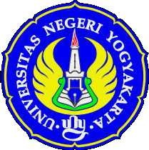

YOGYAKARTA STATE UINIVERSITY 2016
i

YOGYAKARTA STATE UNIVERSITY RECTOR’S REGULATION
NO. 9/2016
ON
FINAL ASSIGNMENT GUIDELINES

BY GRACE OF GOD
RECTOR OF YOGYAKARTA STATE UNIVERSITY

Considering: a. that the final assignment is one of the compulsory pass
courses in all diploma (D3), bachelor (S1), master’s (S2), and doctoral (S3) study programs at the Yogyakarta State University;
- that the final assignment is carried out by students in the form of scientific work based on the results of research and scientific study as one of the requirements for the completion of studies, and is prepared independently under the guidance of a supervisor and determined by the Decree of the Dean or Director of the Graduate School;
- that in order to carry out the final assignment effectively, there need to be final assignment guidelines for students, supervisors, examiners, study programs, departments, faculties/the graduate school, and related parties;
- that the final assignment guidelines based on the Yogyakarta State University Rector’s Regulation No. 14/2015 on Final Assignment Guidelines need to be adjusted to the current development and academic needs of the Yogyakarta State University;
- that based on the considerations as stated in the letter (a), letter (b), letter (c), and letter (d), there needs to be a Rector’s Regulation on the Final Assignment Guidelines;

In view of: | 1. Act No. 20/2003 on National Education System (State Gazette of the Republic of Indonesia No. 78/2003, Supplement to State Gazette of the Republic of Indonesia Number 4301);
2. Act No. 12/2012 on Higher Education (State Gazette of the Republic of Indonesia No.158/2012, Supplement to State Gazette of the Republic of Indonesia Number 5336);
- Government Regulation No. 37/2009 on Lecturers (State Gazette of the Republic of Indonesia No. 76/2009, Supplement to State Gazette of the Republic of Indonesia Number 5007);
- Government Regulation No. 17/2010 on Management and Implementation of Education (State Gazette of the Republic of Indonesia No. 23/2010, Supplement to State Gazette of the Republic of Indonesia Number 5105) as amended in Government Regulation No. 66/2010 on the Amendment on Government Regulation No. 17/2010 on the Management and Implementation of Education (State Gazette of the Republic of Indonesia No. 112/2010, Supplement to State Gazette of the Republic of Indonesia Number 5157);
- Government Regulation No. 4/2014 on Higher Education Implementation and Higher Education Management (State Gazette of the Republic of Indonesia No. 6/2014, Supplement to State Gazette of the Republic of Indonesia Number 5500);
- Presidential Regulation No. 8/2012 on the Indonesian Qualification Framework;
- Regulation of the Minister of National Education of the Republic of Indonesia No. 19/2005 on the National Education Standards;
- Regulation of the Minister of National Education No. 34/2017 on Yogyakarta State University Statutes;
- Regulation of the Minister of Education and Culture No. 98/MPK.A4/KP/2013 on the Appointment of Yogyakarta State University Rector;
- Regulation of the Minister of Education and Culture No. 49/2014 on on the National Standards of Higher Education;
- Yogyakarta State University Rector’s Regulation No. 22/2014 on the Yogyakarta State University Quality Standards;

HAS DECIDED:

To enact: RECTOR’S REGULATION ON THE FINAL ASSIGNMENT GUIDELINES.

Article 1
The final assignment is one of the compulsory pass courses for all students of Yogyakarta State University as one of the requirements in the completion of studies to obtain a Diploma, Bachelor, Master’s, and Doctoral degree.

Article 2
- The final assignment for students of the Diploma programs takes the form of the Final Project.
- The final project as referred to in Clause (1) may take the form of:
  - A master plan or design, can be of a product as part of a complex system or that of a product or device with high efficiency based on problems that occur in the community, business/industry.
  - A product in accordance with the student’s study program in the form of goods, such as equipment, construction, material, food, clothing/costume, prototype/model, software, artwork, and other monumental works and services in the form of improvements of the system, maintenance, and service.
  - Evaluation and testing, can be done to prove a concept or test a product or component.

Article 3
- The final assignment for bachelor students takes the form of Final Thesis Assignment (TAS) or Non-Thesis Final Assignment (TABS).
- Final Thesis Assignment as referred to in Clause (1) takes the form of the scientific paper that reflects students’ ability to carry out scientific thinking processes and patterns through research activities.
- Non-Thesis Final Assignment as referred to in Clause (1) takes the form of a scientific paper that reflect student’s ability to carry out scientific thinking processes and patterns through study or manipulation activities.

